*Florida International University*

*School of Computing and Information Sciences*

Software Engineering Focus

Feature Document

User Story #**235**

**Team Member:**

Jose Morgan

**Product Owner(s)**:

Francisco Ortega

**Mentor(s)**:

Francisco Ortega

**Instructor**: Masoud Sadjadi

**User Story** Implement gesture controls

* As a user I’d like to be able to use the gestures supported by the input devices with the application.

Acceptance Criteria

* Many of the common gestures should be functioning with the application.
* Gestures should be handled concurrently by different devices.
* Implementation should be done in such a way that it can be extended when it is time to move to Vulkan.

Use Case - Painter connects an input device to the application. The user is then able to draw using both hand tracking and gestures.

**Use Case Diagram**



**Sequence Diagram**

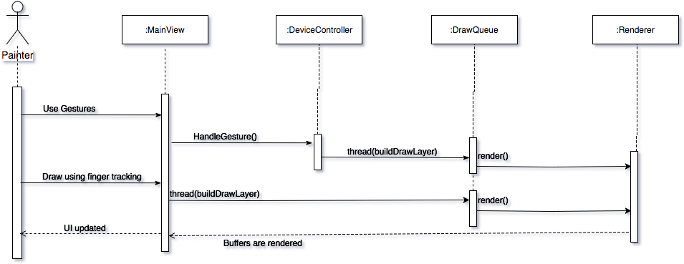

**Class Diagram**

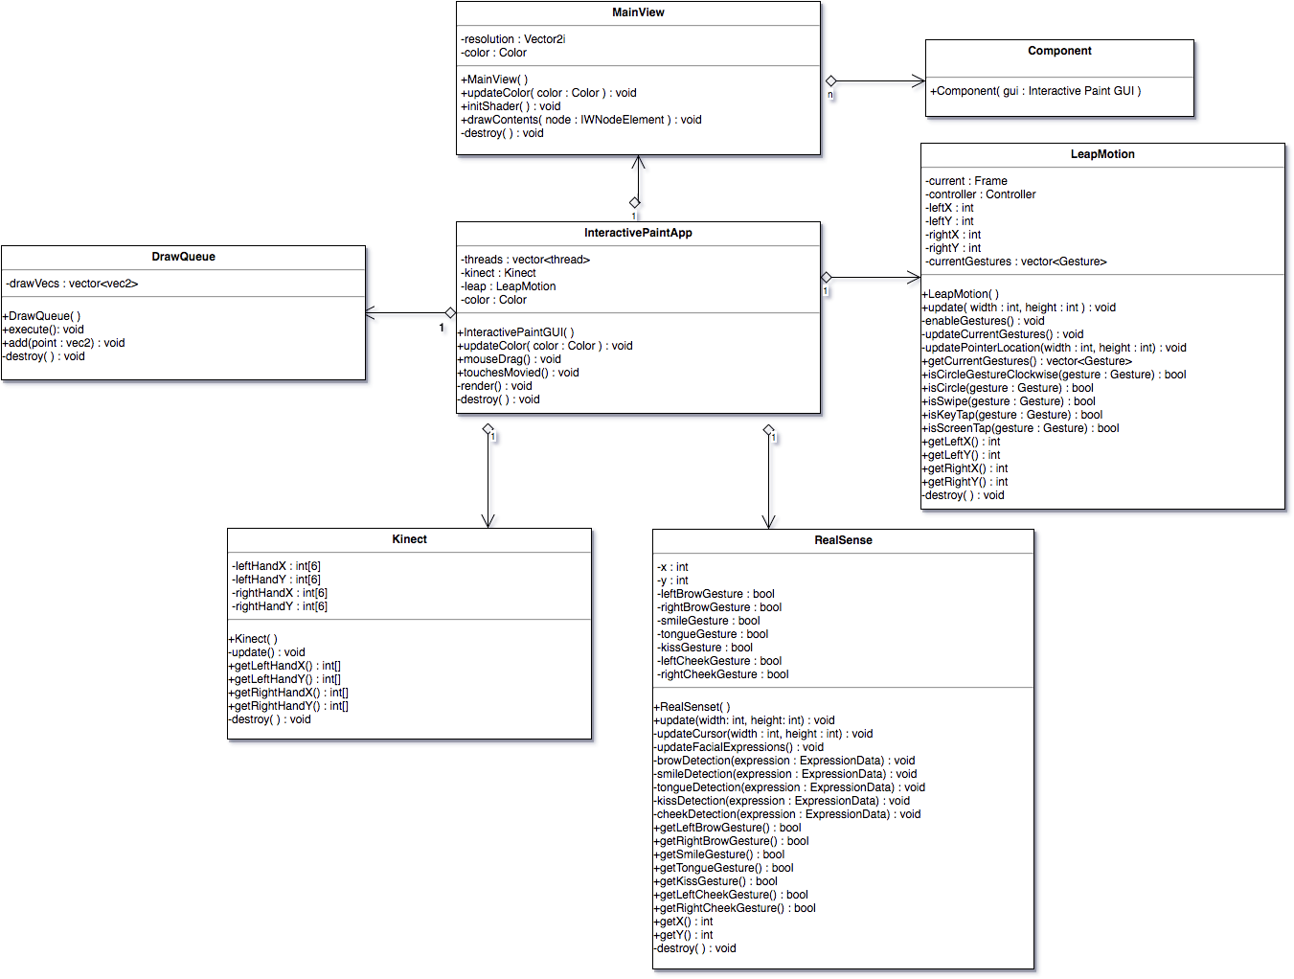

**Unit Tests**

**Sunny Day Tests**

LeapMotion update method

Left and Right finger locations were forced to x = 0.5 y = 0.5

Input: screen height = 720, width = 1280

Expected Result: left and right finger locations should become x = 640 y = 360

Actual Result: left and right finger locations were x = 640 y = 360

RealSense update method

Cursor location was forced to x = 0.5 y = 0.5

Input: screen height = 720, width = 1280

Expected Result: cursor location should become x = 640 y = 360

Actual Result: cursor location became x = 640 y = 360

DrawQueue execute method

DrawQueue vector filled with {(20,20), (30,30), (40,40), (50,50)}

Expected Result: On the screen there should be white dots at positions 20, 20; 30, 30; 40, 40; and 50, 50.

Actual Result: On the screen there were white dots at positions 20, 20; 30, 30; 40, 40; and 50, 50.

LeapMotion isCircleGestureClockWise method

Input: Clockwise circle gesture

Expected Result: True

Actual Result: True

**Rainy Day Tests**

LeapMotion isCircleGestureClockWise method

Input: Swipe gesture

Expected Result: False

Actual Result: False

**Integration Tests**

Multiple users used the application with different input devices for several minutes using gestures and hand tracking.

**Visual User Guide**

First start off by connecting some input device. Once that input device is connected you can start using gestures to do certain functionality in the application.

